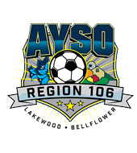 | Sponsored by AYSO Region 106 Lakewood-Bellflower  Annual AYSO FOX & HARE  Invitational Tournament  Referee Plan | 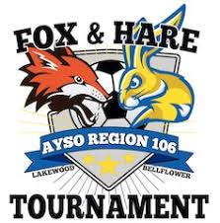

The following are guidelines that the AYSO Fox and the Hare Invitational Tournament will apply for referees in our 2019 tournament:
Commitment Requirements | - Referees will be provided by the tournament for all pool play, semi-final, and finals games.  - Teams entering the tournament will not need to provide a referee team crew, nor send a referee deposit.  - Referee’s for 8U-19U will be covered by Beach Cities Soccer Referee Association (B.A.S.R.A.).
Contact Information: | Questions regarding referee requirements should be directed to: ERIK VEACH  Call (310) 662-1448  E-mail RA@AYSO106.ORG  Web site www.AYSO106.org

